DSA Semester Project

Submitted by:
Rameen Ezwa Janjua
Noor Sidra
BS Artificial Intelligence – 3rd Semester
Course:
Data Structures & Algorithms

Project Title:
Ride-Sharing Dispatch & Trip Management System

Submitted To:
Prof.Usman Ali

1. Project Overview
This project simulates a ride-sharing system similar to Uber or Careem.
It includes:
- City represented as a weighted graph
- Driver and Rider management
- Trip state management
- Trip cancellation and rollback
- Analytics and reporting

2. Team Structure
Team Members:
- Student 1: Rameen Ezwa Janjua
- Student 2: Noor Sidra
Responsibilities:
- Both members are responsible for coding, integration, testing, and documentation.

3. System Architecture
The system is divided into multiple modules:
- City Module
- Driver Module
- Rider Module
- Trip Module
- Dispatch Engine
- Rollback Manager
- RideShare System
- Main Program

4. Class Design
4.1 City
- Graph represented using custom adjacency structure
- Stores roads and zones
- Supports:
  - addRoad()
  - setZone()
  - shortestPath()
  - shortestPathWithZoneCost()

4.2 Driver
- Attributes:
  - id
  - location
  - availability
- Functions:
- setAvailable()
- isAvailable()
- getLocation()

4.3 Rider
- Attributes:
  - id
  - pickup
  - dropoff

4.4 Trip
- Trip states:
  - REQUESTED
  - ASSIGNED
  - ONGOING
  - COMPLETED
  - CANCELLED
- Functions:
  - startTrip()
  - completeTrip()
  - cancelTrip()

4.5 Dispatch Engine
- Manages driver list
- Finds best driver using shortest path
- Creates new trip

4.6 Rollback Manager
- Stores trip history
- Supports:
  - rollback last trip
  - rollback k trips
- Restores driver availability on rollback

4.7 RideShare System
- Integrates Dispatch Engine and Rollback Manager
- Provides user API:
  - requestRide()
  - cancelLastTrip()
  - startLastTrip()
  - completeTrip()
  - printAnalytics()

5. Trip State Machine
Valid transitions:
REQUESTED → ASSIGNED → ONGOING → COMPLETED
REQUESTED → CANCELLED
ASSIGNED → CANCELLED
Invalid transitions are blocked by checking state before changing.

6. Rollback Strategy
Rollback works by:
- Storing every trip in history
- When rollback is called:
  - Cancel trip
  - Restore driver availability
  - Remove trip from history
Rollback operations supported:
- rollback last trip
- rollback k trips

7. Graph Representation
City graph uses custom adjacency lists:
- Each node contains a list of connected nodes
- Each road stores:
  - destination
  - distance
No STL graph or map containers used

8. Shortest Path Algorithm
Used algorithm: Dijkstra
Steps:
- Start from source node
- Use custom priority logic (no STL priority queue)
- Update shortest distance for each neighbor
- Return shortest distance to destination

9. Analytics Module
Analytics includes:
- Average Trip Distance
- Driver Utilization
- Cancelled vs Completed Trips
These are calculated using the trip history list.

10. Time & Space Complexity
10.1 Shortest Path
- Time Complexity: O(V^2) (because no STL PQ)
- Space Complexity: O(V)
10.2 Driver Search
- Time Complexity: O(N) where N is number of drivers
- Space Complexity: O(1)
10.3 Rollback
- Time Complexity: O(k) for rollback of k trips
- Space Complexity: O(T) where T is number of trips stored

11. Testing
Test Cases (Implemented in main.cpp)
- Graph creation test
- Shortest path correctness
- Zone cost shortest path
- Driver addition
- Ride request and driver assignment
- Trip start state transition
- Trip completion
- Trip cancellation
- Rollback functionality
- Analytics output validation

12. Final Output Screenshot
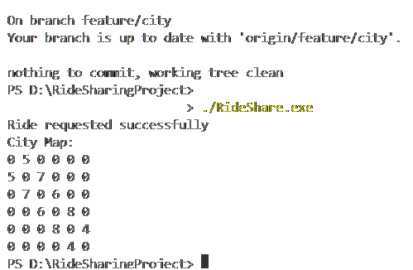

13. Conclusion

The system meets all functional requirements:
- Custom graph structure
- Valid trip state transitions
- Rollback and cancellation
- Analytics and history
- Testing completed successfully

